Question 02
- What is Boolean? Write down 3 different expression that results a Boolean type (i.e. 5==6)
- Boolean is an expression that evaluates to produce a result which is a Boolean value.
- 3 different expression that results a Boolean type:
+ >>> 15 == (3*5)
True
+ >>> age =18
>>> old_enough_to_travel_alone = age >= 18
Print(old_enough_to_travel_alone)
True
+ >>> 20 != 20
False

- What is a flow chart? Draw flow chart for the following code snippet:
A flowchart is a type of diagram that represents an algorithm, workflow or process.
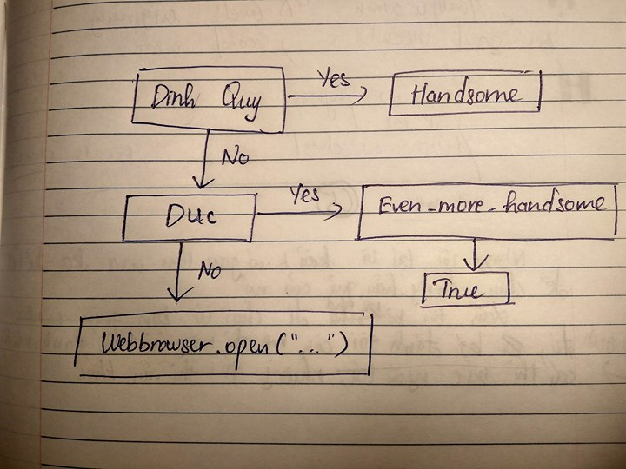

- What is nested conditionals? Write a piece of code that uses nested conditionals.
- One conditional can also be nested within another.

- A piece of code that uses nested conditionals:
if Lan < Mai:
print(“Lan is younger than Mai.”)
else:
if Lan > Mai:
print(“Lan is older than Mai.”)
else:
print(“Lan is as old as Mai.”

